Search Online Member Directory at your app store, or use the following links:
- Apple app
- Android app
- On the welcome screen, select ADD NEW DIRECTORY

- Enter the mobile code that was provided to you. SHARONBAPTISTNC
(*Don’t know your mobile code? See below.)
- Touch the name of the organization when it appears
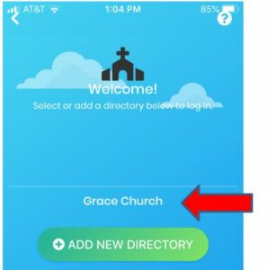
SHARONBAPTISTNC
- Log in with your username and password, and select Remember Me.
- Password provided by directory administrator (Terrie Hauck)

